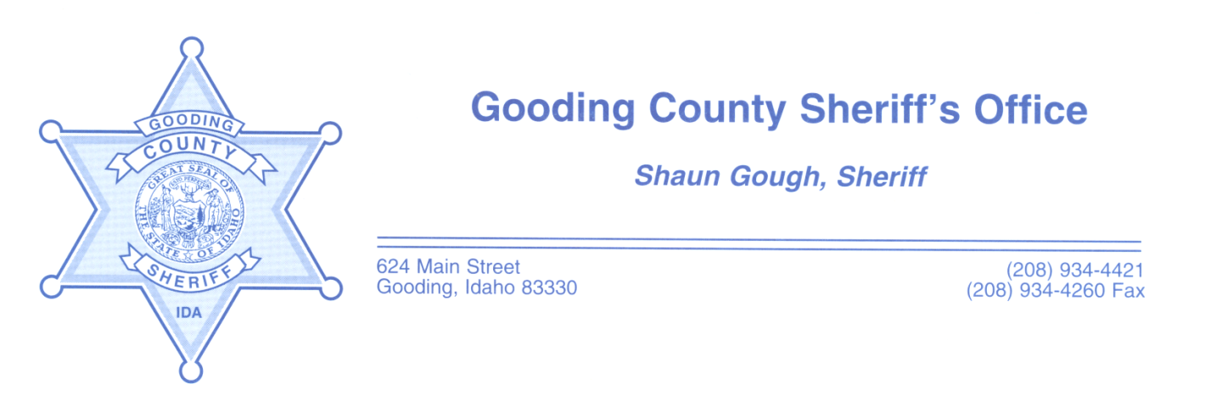
JOB OPENING
Job Title: Detention Deputy-Position is open until filled.
Starting Pay: $23.11 an hour. Pay increases to $23.73/hour after certification through the Idaho P.O.S.T. Academy. Shifts are 12 hours long and you will work 14 days during a 28 day pay period. Every other weekend is a 3-day weekend.
Benefits: Medical/Dental/Vision/Life paid for employees, P.E.R.S.I. retirement, and over 200 hours of paid time off a year.
Job Description: Deputies are responsible for the supervision of inmates and the security of the court house. Deputies intake and release new inmates, conduct searches on inmates and cells, transport inmates, monitor cameras, phone systems, conduct security checks, oversee court proceedings, and assist with the medical needs of inmates.
Requirements are:
• Must be at least 18 years of age
• High School Diploma or G.E.D
• Be able to pass the P.O.S.T. physical test (requirements can be found on the Idaho P.O.S.T. website)
• Work rotating weekends, holidays, day shift, swing, or night shift (12-hour shifts)
• Valid Idaho drivers’ license
• Pass a polygraph
• Must pass back ground check
Applications can be picked up at the Gooding County Sheriff's Office located at 624 Main St. Gooding, ID. 83330, or downloaded from the website at: http://www.goodingcounty.org/157/Sheriff
The Gooding County Sheriff's Office always accepts applications. We are a drug free, equal opportunity employer.

